8. Additional marketing materials

The inspiration behind our design stems from the smart technology used to map real-time traffic data in “smart cities”. Our goal is to assist business owners to achieve their objectives.

In the diagram bellow are listed all of the advances offered by “smart cities”.

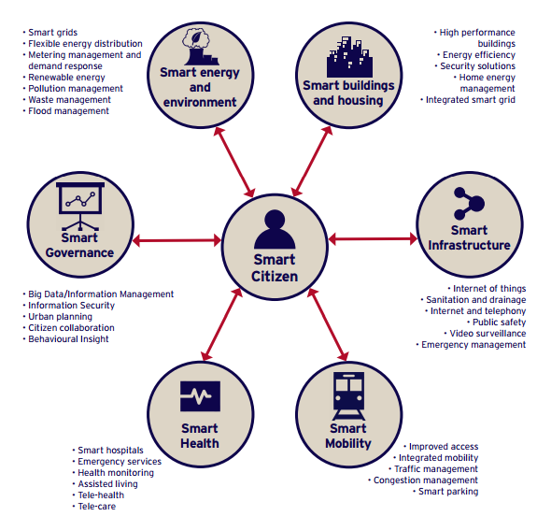
Source: HM Government (2016) ‘Smart cities Pitchbook’

Cities are real-time systems, and a “smart city” is made up of several smart systems. An intelligent city will have smart physical, social, institutional and economic infrastructure in a sustainable environment, with its citizens at the center of these systems.

In order to fulfill our mission we have focused on Smart Governance, Smart Infrastructure and Smart Mobility by merging and layering data from private and public domains.

All of this data can be utilized by prospective clients in order to discover areas and markets in which they can position themselves. Through the use of geolocation and population density measurements clients can make a predictive model of trends on how their potential consumers move and behave in a given vicinity. This can help to determine what type of advertisements are most effective, what products to offer and if they need to reposition or refocus themselves in the market in order to achieve the highest level of consumer satisfaction, reputation boost and revenue increase.

References

Department for Business, Innovation and Skills. (2013) ‘The Smart City Market: Opportunities for the UK’. Available at: https://www.gov.uk/government/uploads/system/uploads/attachment_data/file/249423/bis-13-1217-smart-city-market-opportunties-uk.pdf (Accessed: 20 October 2016).

Frost and Sullivan ‘Strategic Opportunity Analysis of the Global Smart City Market’, Available at: http://www.egr.msu.edu/~aesc310-web/resources/SmartCities/Smart%20City%20Market%20Report%202.pdf (Accessed: 20 October 2016)

HM Government (2016) ‘Smart cities Pitchbook’. Available at: https://www.gov.uk/government/uploads/system/uploads/attachment_data/file/526238/Smart_Cities_Pitchbook.pdf (Accessed: 21 October 2016).

Mitchell, S., Villa, N., Stewart-Weeks, V. and Lange, A. (2013) ‘The Internet of Everything for Cities Connecting People, Process, Data, and Things To Improve the “Livability” of Cities and Communities’, Available at:https://www.cisco.com/c/dam/en_us/solutions/industries/docs/gov/everything-for-cities.pdf (Accessed: 20 October 2016) Cisco, .

‘Road Traffic Estimates: Great Britain 2014 (R)’ (2014) Department for Transport, Available at: https://www.gov.uk/government/uploads/system/uploads/attachment_data/file/487689/annual-road-traffic-estimates-2014.pdf (Accessed: 20 October 2016).

